**Nguyễn Nam Khánh – HE191159 – IA1902 – IAM302**

**LAB 1: Setting Up Environment**

**Setup Inetsim configuration for Kali**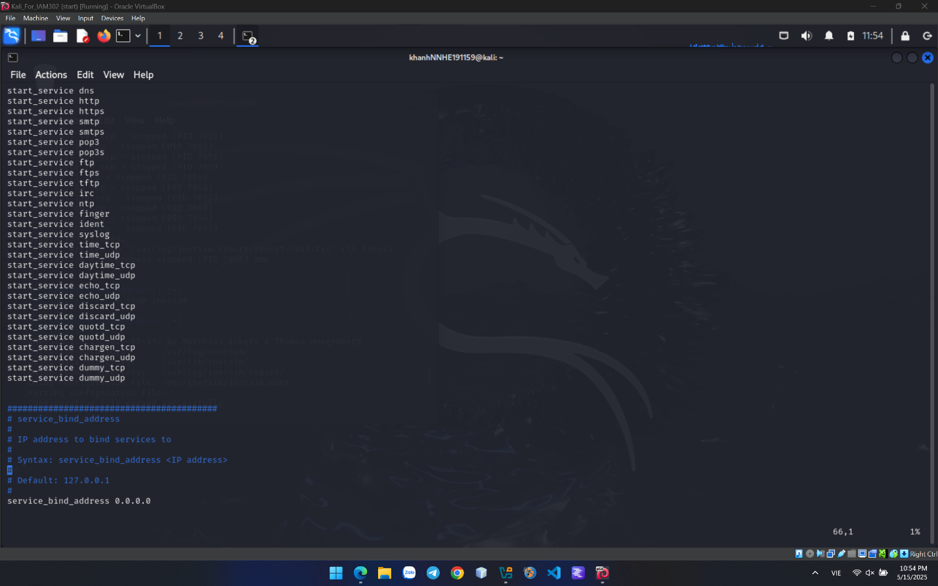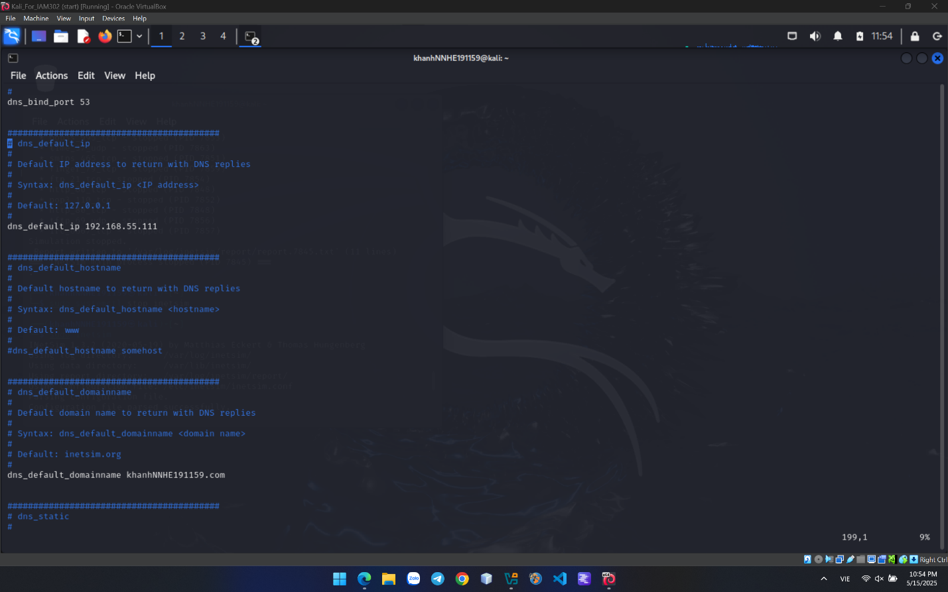

**Viewing an HTTP Web Page**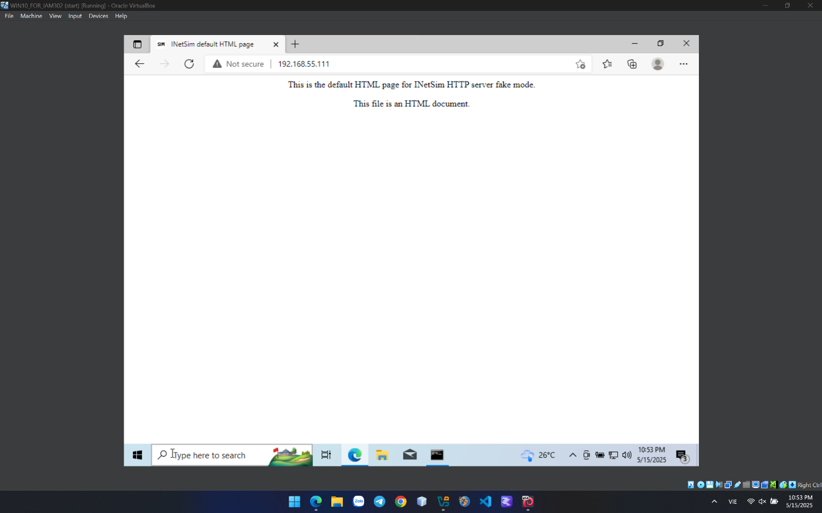

**Start Nmap**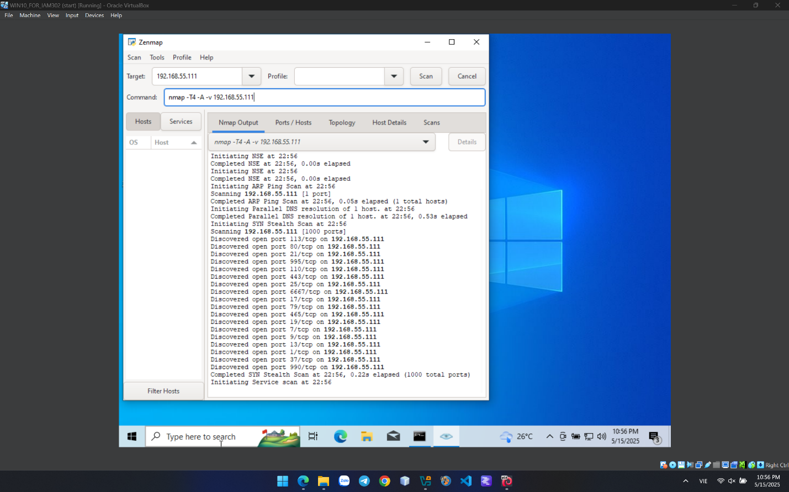

**Nguyễn Nam Khánh – HE191159 – IA1902 – IAM302**

**BÀI CRACKME 1**

**Open the CrackMe1.exe file and test it with a random serial key, resulting in the message "Wrong serial key. Try again." This is a critical indicator, as it will guide us to locate the correct serial key in subsequent steps by analyzing the related code.**

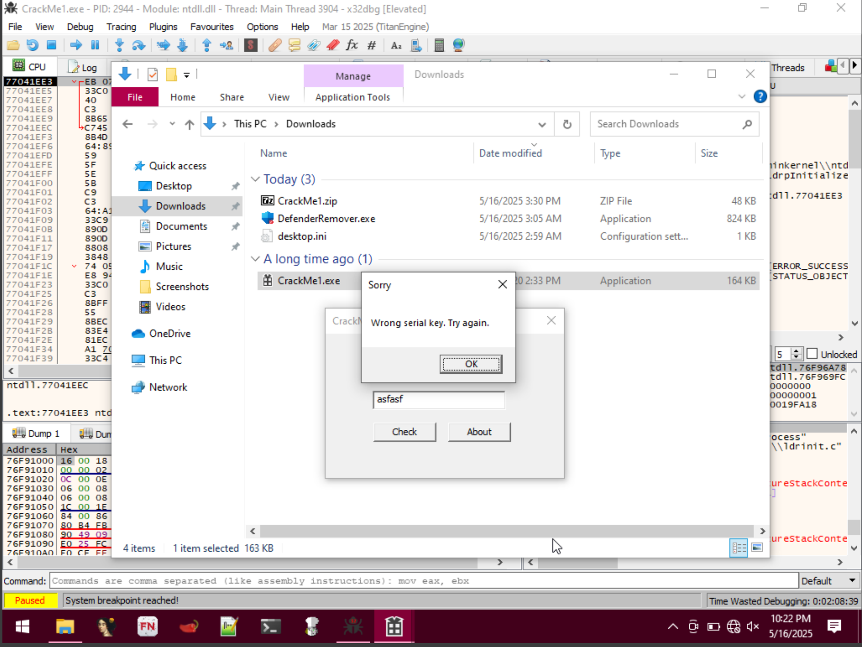

**Open the CrackMe1.exe file in x32dbg to start the analysis.**

**Note: x32dbg is a debugger used to analyze the program's machine code (assembly). The CPU tab displays the assembly instructions we will examine.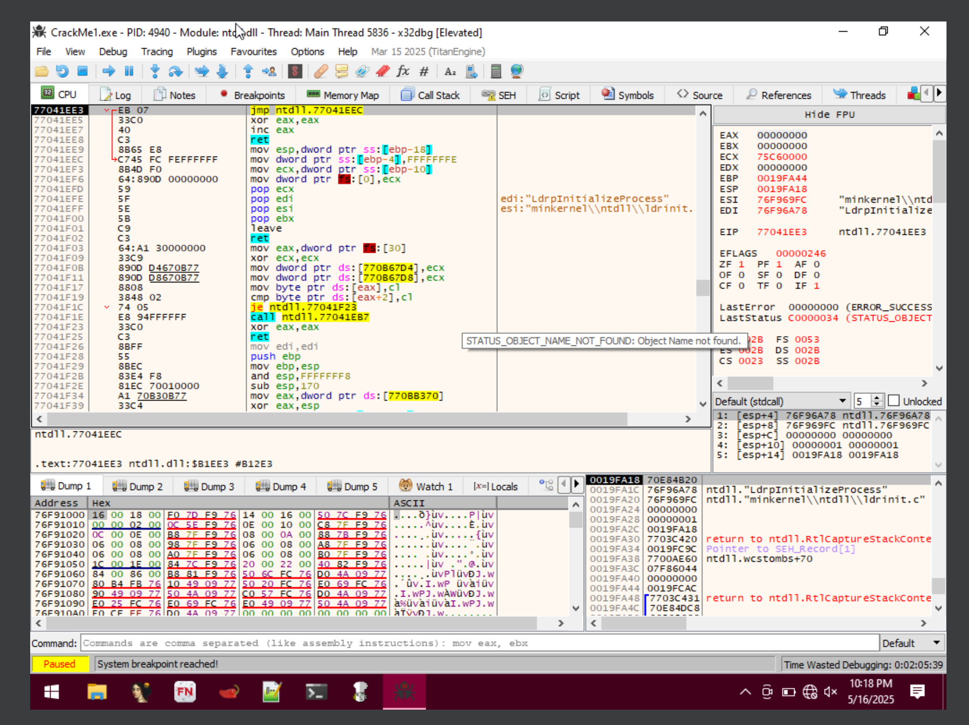Right-click, scroll to "Search for" => "All User Modules" => "String References" to view the mappings of meaningful strings to hexadecimal values stored at addresses in the assembly code.**

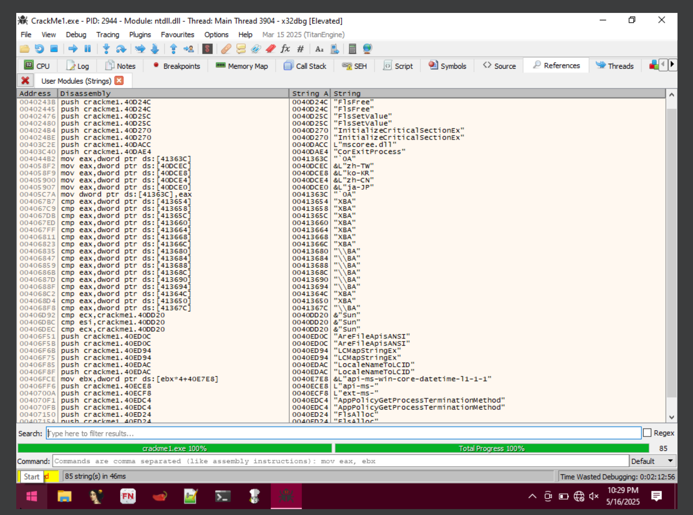

**Then search for the string "Wrong serial key. Try again." which we noted during the initial test run of the .exe file.**

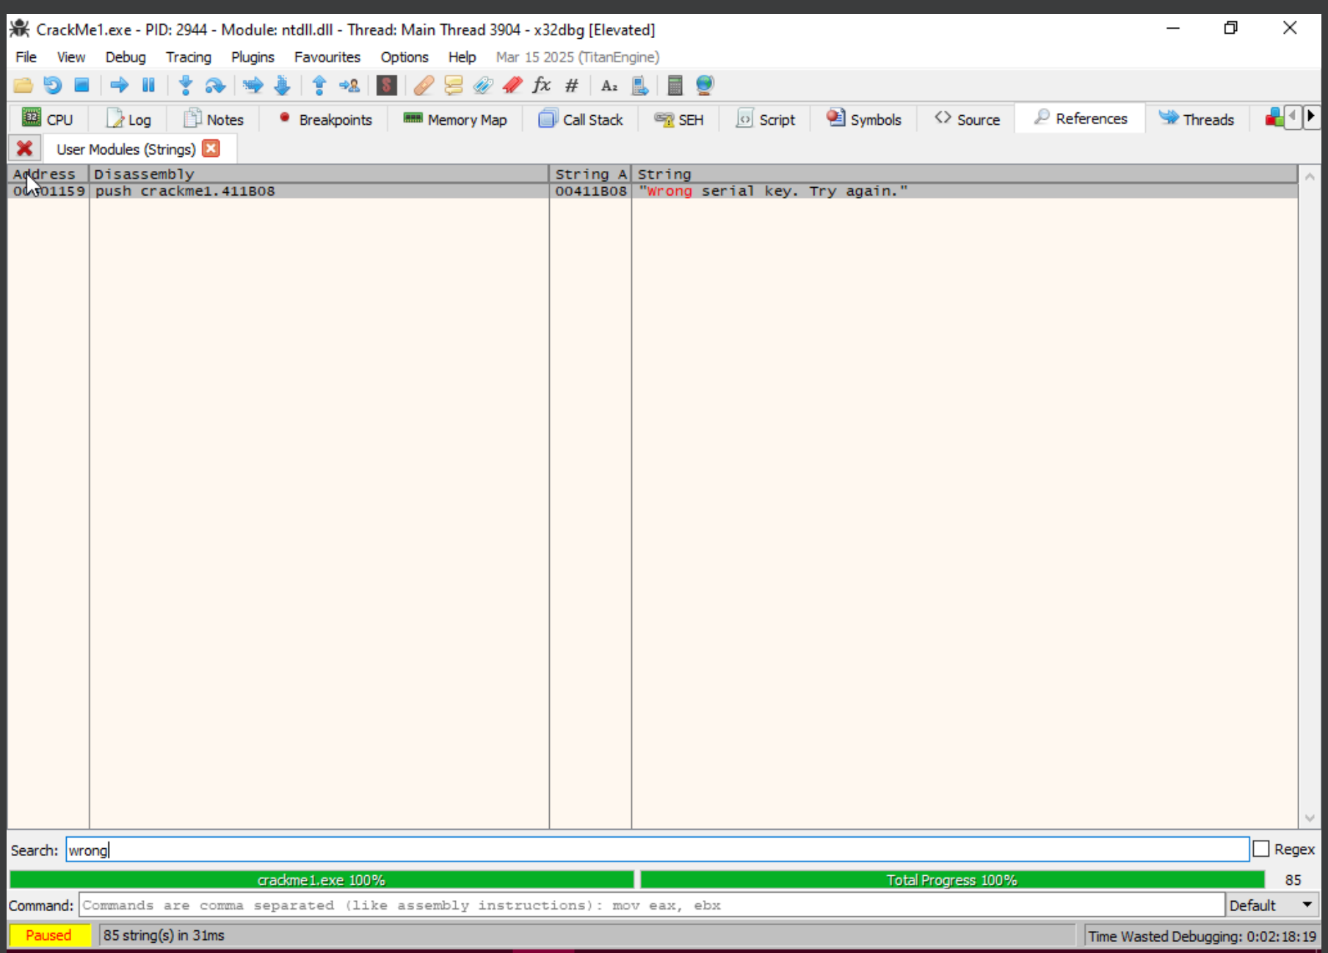

**Double-click the string "Wrong serial key. Try again" to jump to its location in the assembly code (address 00401159).**

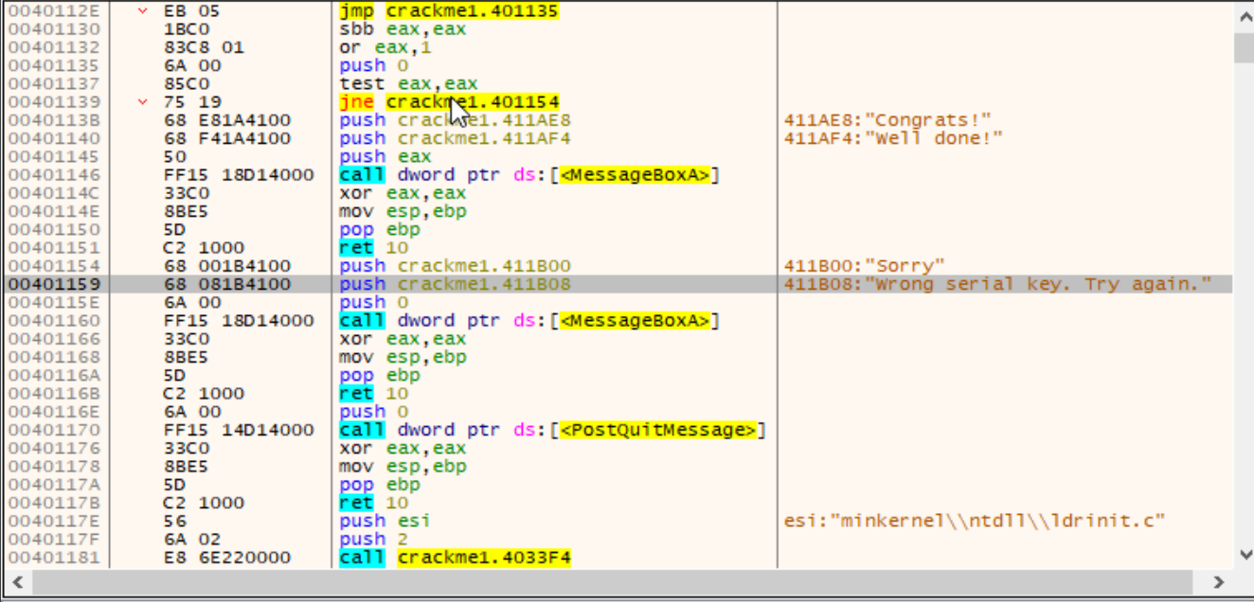

**Note: This string is the message shown when the serial key is incorrect. Locating this string helps identify the code section that checks the serial key, typically just before the string is called.  
From the "Wrong serial key. Try again" string at address 00401159, scroll up to find the CMP instruction that performs the serial key comparison. The CMP instruction is found at 00401112, where “MOV ECX, crackme1.411AD8” assigns the value "cr4ckingL3ssons" to ECX. Then, CMP compares DL (each byte of input string) with ECX. If they don't match, the program jumps to the failure branch and displays “Wrong serial key. Try again”.**

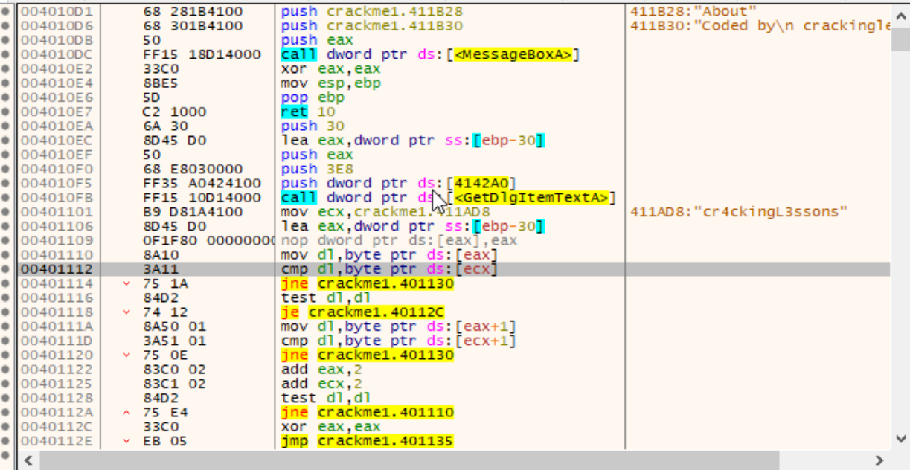 **Set a breakpoint at address 00401112 to inspect the values of registers (such as DL and ECX) during the serial key comparison, aiming to identify the correct value. Press F9 to execute the program, enter a random key ("ngocanh"), and the program will pause at the breakpoint for analysis.**

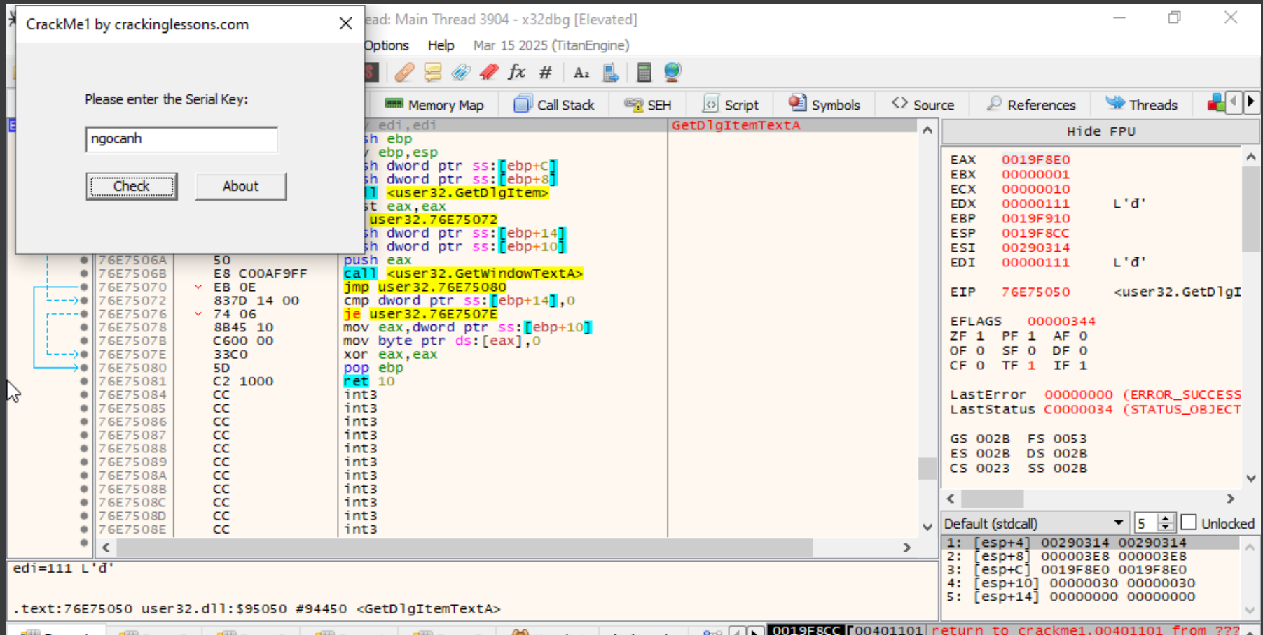

**Press F8 to step through the code until the breakpoint, focusing on the register window with variables EAX, ECX, and ESP. Observe their changes after each code step.**

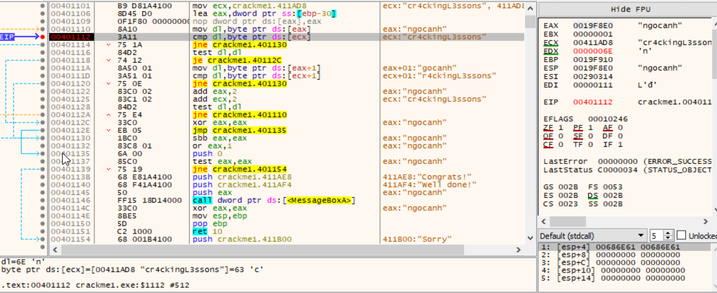

**At the breakpoint, we observe that the first byte of EAX (stored in DL) is 'n', while the ECX string starts with 'c'. This raises doubts about the accuracy of "cr4ckingL3ssons" as the correct serial key.**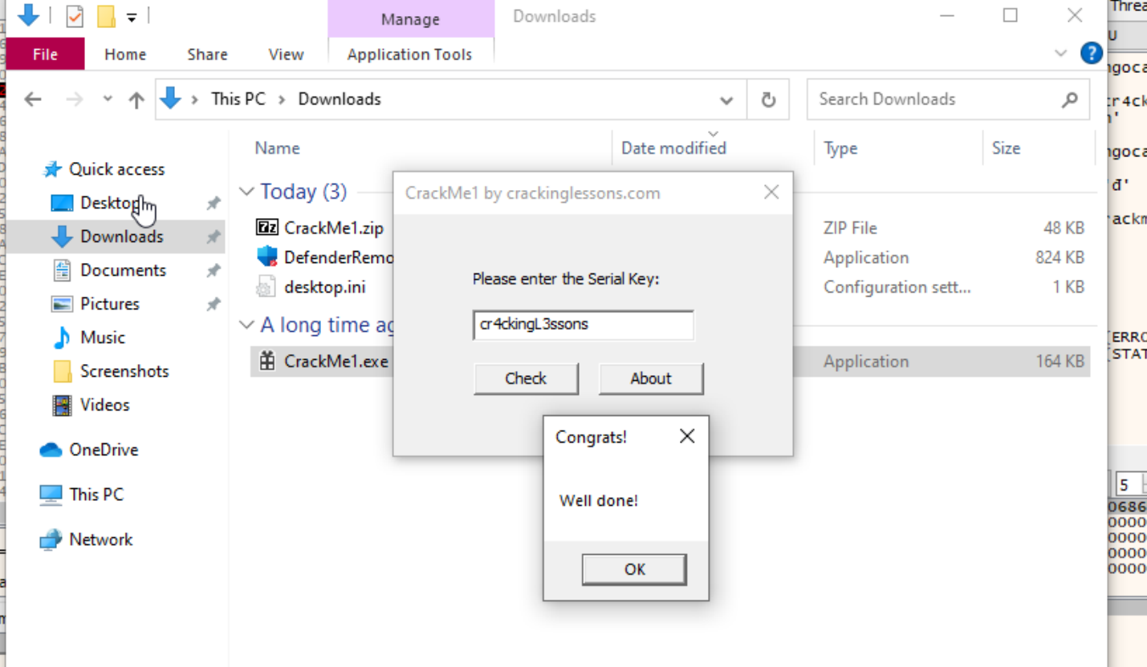

**Test the CrackMe1.exe file, resulting in the message "Well done!"**

**Conclusion: The serial key is "cr4ckingL3ssons".**

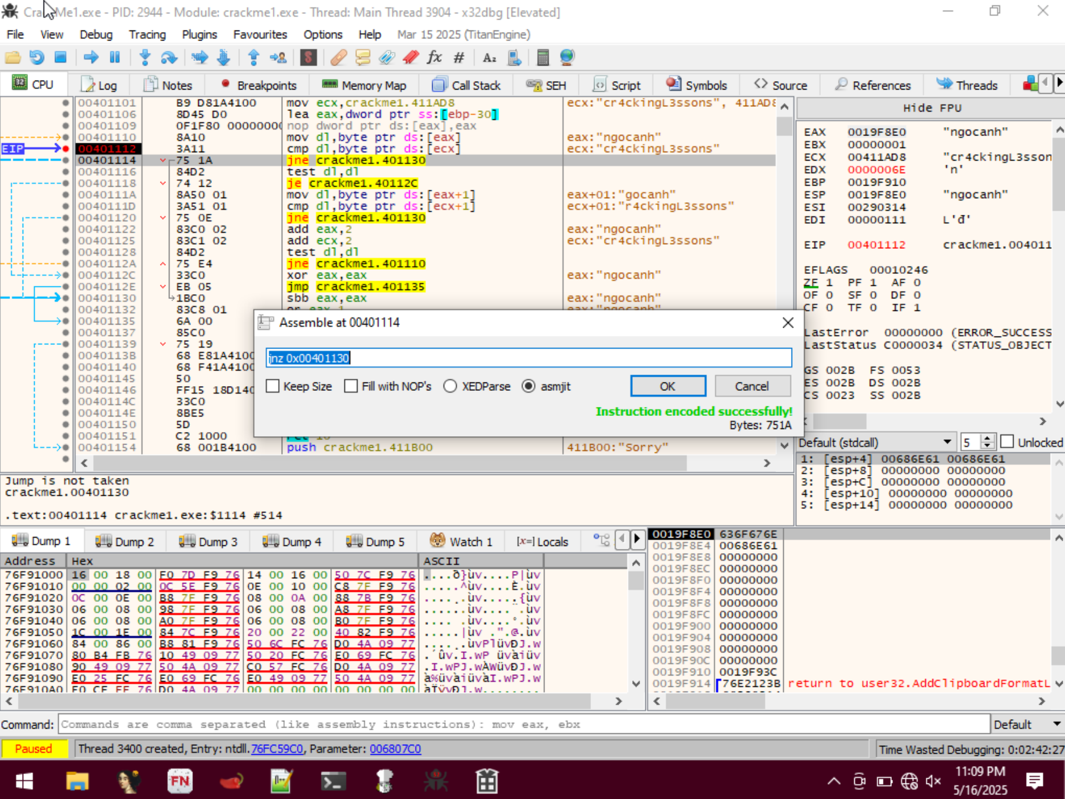

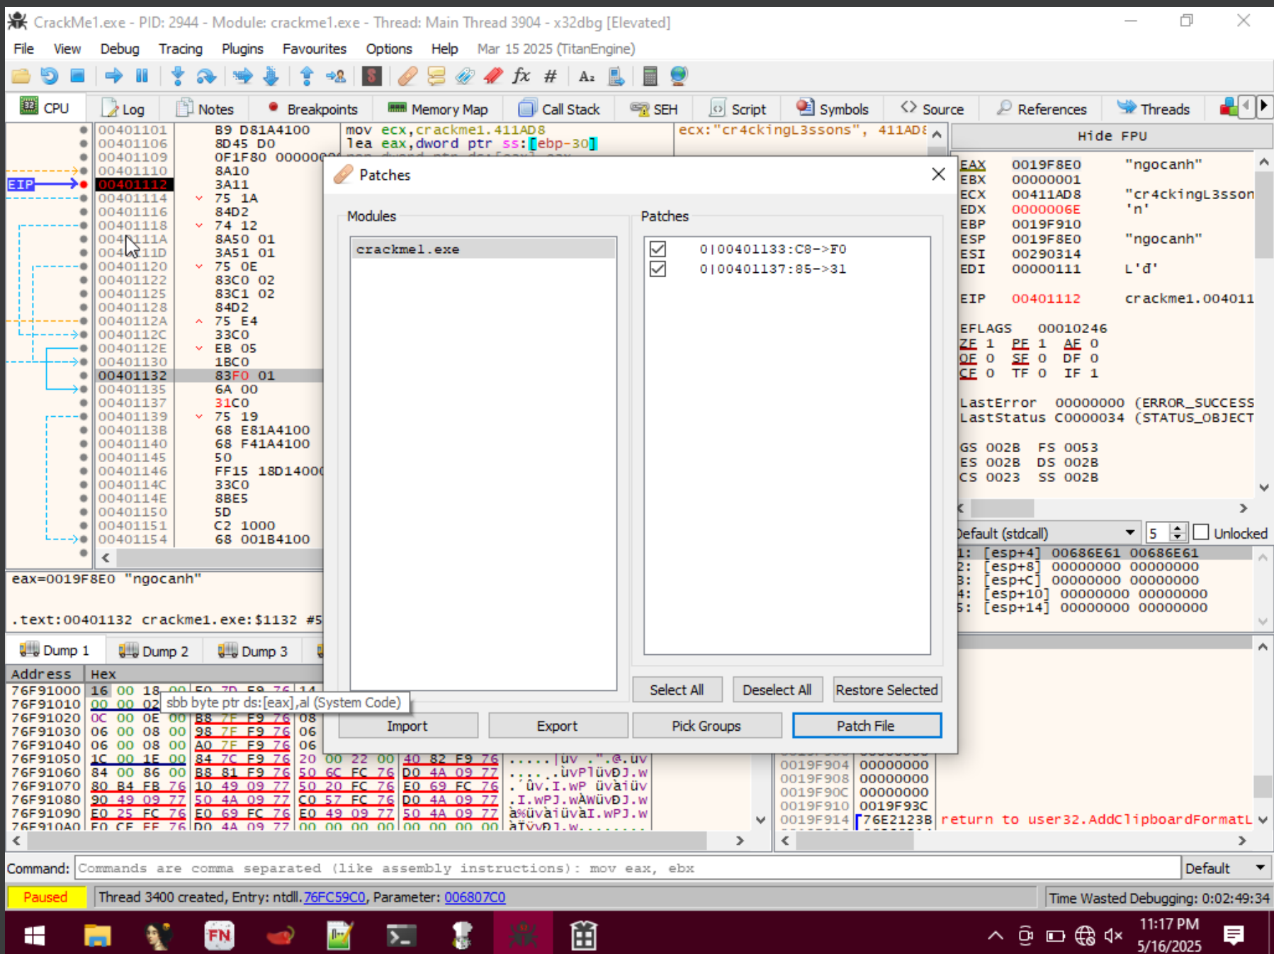

**Convert test eax,eax to xor eax eax and patch file**

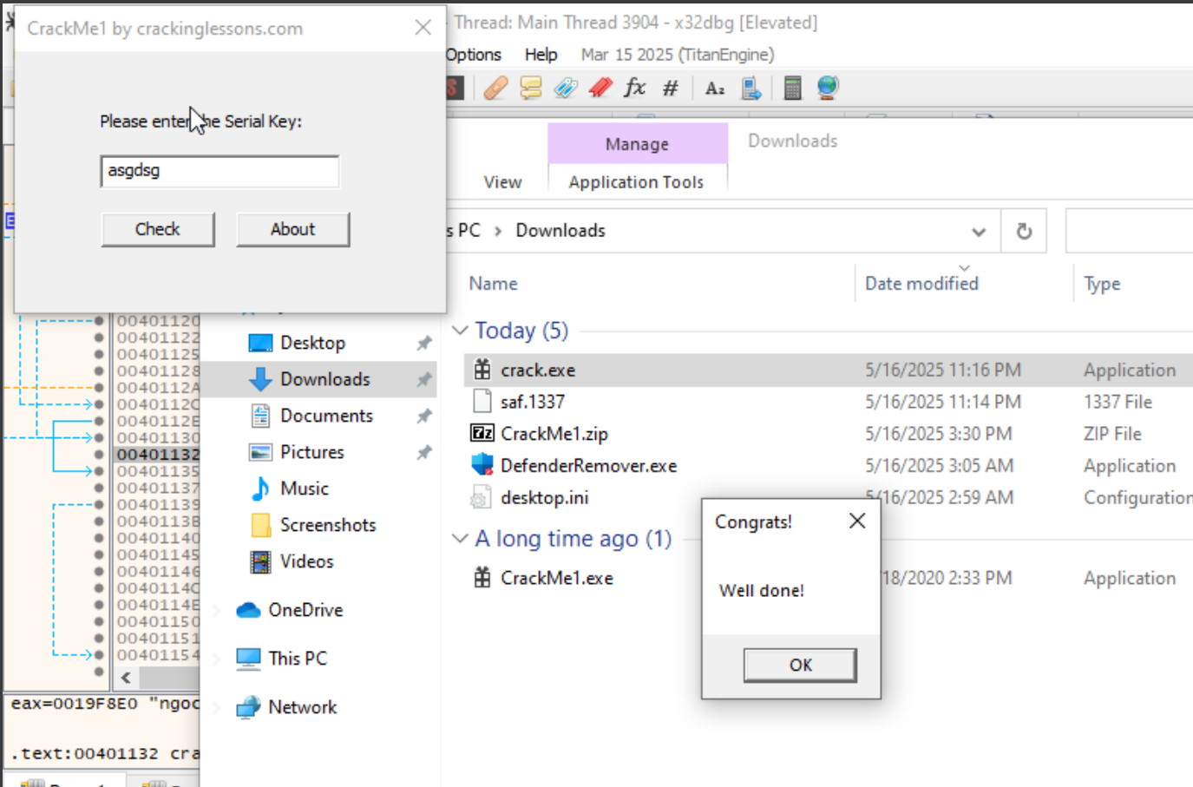**then check random key and bypass!**